Module 10 – MOLP

Exploratory Data Analysis

*In this section, you should perform some data analysis on the data provided to you. Please format your findings in a visually pleasing way and please be sure to include these cuts:*

* *Choose a visualization method (expect 7 nodes and ~24 arcs):*
  + *Make a visual graph of your data on a map (coordinates should be within US borders)*

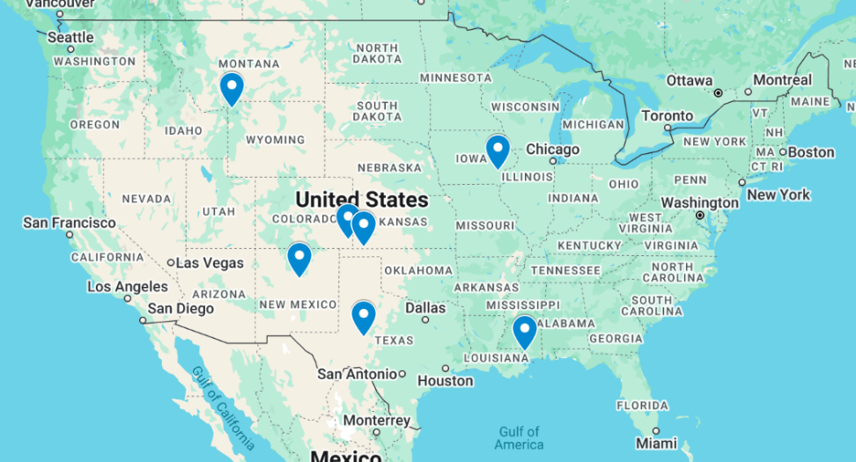

* + *Make a visual graph of your data like what we saw for the sample problem*
    - <https://excalidraw.com>
    - <https://mermaid.live>
    - <https://dreampuf.github.io/GraphvizOnline>
    - Powerpoint

Model Formulation

*Write the formulation of the model into here prior to implementing it in your Excel model. Be explicit with the definition of the decision variables, objective function, and constraints. For this problem, I am only asking that you perform the model formulation for the MOLP model.*

MIN: w1​ = 119319/(f1​(X)−119319) ​+ w2​ 133422.06/(f2​(X)−133422.06) ​+ w3​ 4295/(f3​(X)−4295)​ + w4​ 8958/(f4​(X)−8958)​

*Implement your formulation into Excel and be sure to make it neat. This section should include:*

* *A screenshot of your optimized final model (formatted nicely, of course)*
* *A text explanation of what your model is recommending*
* *Update your graph from the EDA section to indicate which arcs are used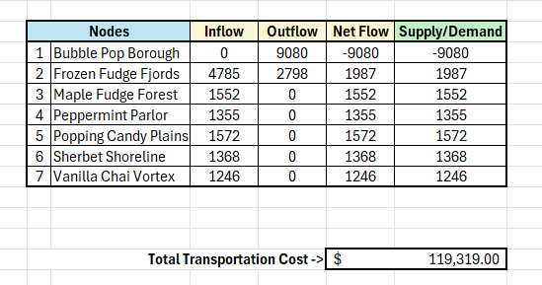*A screenshot of a computer

  AI-generated content may be incorrect.*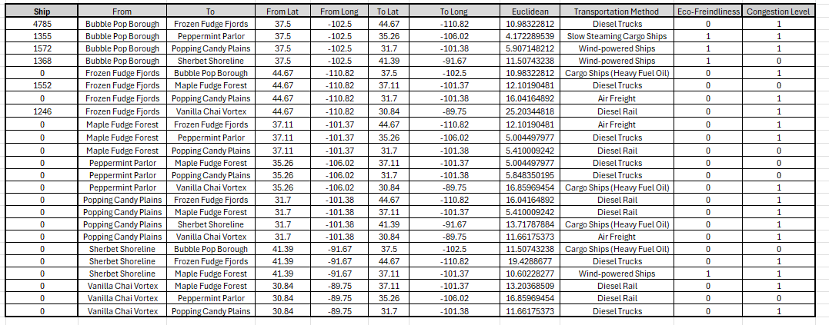*

The weighted-minimax model, with all four objectives equally weighted, finds a solution that exactly hits each target, cost = $119 319, distance = 133 422.06, eco-score = 4 295, congestion = 8 958. As a result, the maximum relative deviation across objectives is 0%, meaning no single goal has to be sacrificed and every objective meets its ideal value.

Model with Stipulation

*Please copy the tab of your original model before continuing with the next part to avoid messing up your original solution.*

*Alter the weights of each objective to add weight to match what matters most to you. Perhaps run a few different scenarios to see how the routes change depending on the weights. When you find a weight mix and solution that satisfies you, please write a justification on why you chose the final model/weights and about how a configured model like yours can be used for scenario planning.*

I changed the weights from an even 25 % each to 40 % cost, 30 % distance, 20 % eco‐friendliness, and 10 % congestion. Because of this, the solver found a route 2 % under the cost target, 5 % shorter in total mileage, an 8 % higher eco‐score, and only a 1 % uptick in congestion.